DB Status Change Alert - SQL Server.
https://www.sqlshack.com/send-an-alert-when-the-database-state-changes-to-sql-server-single-user-mode/
- This article explains the SQL Server single-user mode and how to configure an automated email alert when the state of the user database changes to the single-user mode.
- To send an alert, we will create a DDL trigger that executes when the user runs the ALTER DATABASE query.
- It collects the pieces of information using EVENTDATA() function, saves it in a temporary table, and sends an HTML formatted email.

Configure the SQL Server Database Mail
SQL Server Database Mail is used to send the email using the Database Engine. This is handy when we want to send the query result, configure any alert or notification. SQL Server Database Mail uses the SMTP protocol to send emails.
Now, to send the email notification, I am going to use my personal email account. I am using Microsoft Outlook; hence, I will use the SMTP configurations of Microsoft Outlook. I am adding SMTP server details of Gmail Outlook and Microsoft Live/Hotmail.
Mail service providers | SMTP server name | Port
Microsoft Hotmail | smtp.live.com | 587
Gmail | smtp.gmail.com | 587
Microsoft Outlook | smtp.office365.com | 587

To configure the database mail, you should enable the database mail feature in SQL Server. To do that, you must run the following query in sequence:
/*Enable advanced option*/
sp_configure 'show advanced options', 1;
GO
RECONFIGURE;
GO
/*Enable database mail*/
sp_configure 'Database Mail XPs', 1;
GO
RECONFIGURE
GO

/*Configure SQL Database mail using the SMTP server of Microsoft Outlook*/

/*Configure SQL Database mail using the SMTP server of Microsoft Outlook*/
EXECUTE msdb.dbo.sysmail_add_account_sp
@account_name = 'Database_Mail_Account',
@email_address = 'nisargupadhyay87@outlook.com',
@mailserver_name = 'smtp.office365.com',
@port=587,
@enable_ssl=1,
@username='nisargupadhyay87@outlook.com',
@password='<YourPassword>'

/*Create database mail profles*/
EXECUTE msdb.dbo.sysmail_add_profile_sp
@profile_name = 'Database_Mail_Profile',
@description = 'DB Mail Service for SQL Server'

/*Add database mail account to the profile*/
EXECUTE msdb.dbo.sysmail_add_profileaccount_sp
@profile_name = 'Database_Mail_Profile',
@account_name = 'Database_Mail_Account',
@sequence_number =1 ;

/*Grant access to the database mail profile*/
EXECUTE msdb.dbo.sysmail_add_principalprofile_sp
@profile_name = 'Database_Mail_Profile',
@principal_id = 0,
@is_default = 1
We can review Database Mail settings by executing the following query:
SELECT p.NAME AS ProfileName,
email_address AS [EmailAddress],
display_name AS [Display Name],
servername AS [SMTP Server Name],
port AS [Prot Number],
enable_ssl AS [Is SSL enabled?]
FROM msdb.dbo.sysmail_profile p
JOIN msdb.dbo.sysmail_profileaccount pa
ON p.profile_id = pa.profile_id
JOIN msdb.dbo.sysmail_account a
ON pa.account_id = a.account_id
JOIN msdb.dbo.sysmail_server s
ON a.account_id = s.account_id
Sample Output:
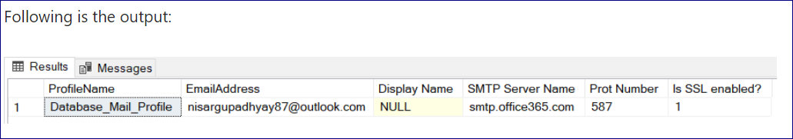
Following is the entire script of the database trigger:
USE MASTER
GO
IF EXISTS (SELECT * FROM sys.server_triggers
WHERE name = 'ddl_trig_changedbstat')
DROP TRIGGER ddl_trig_changedbstat
ON ALL SERVER;
GO
CREATE TRIGGER ddl_trig_changedbstat
ON ALL SERVER
FOR ALTER_DATABASE
AS
create table #TempAudit (Command varchar(50),SQLCommand varchar(5000),LoginName varchar(100),DBName varchar(500))
Insert into #TempAudit
SELECT EVENTDATA().value('(/EVENT_INSTANCE/EventType)[1]','nvarchar(max)') ,
EVENTDATA().value('(/EVENT_INSTANCE/TSQLCommand/CommandText)[1]','nvarchar(max)') ,
EVENTDATA().value('(/EVENT_INSTANCE/LoginName)[1]','nvarchar(max)') ,
EVENTDATA().value('(/EVENT_INSTANCE/DatabaseName)[1]','nvarchar(max)')
DECLARE @subject NVARCHAR(max)
DECLARE @tableHTML NVARCHAR(max)

SET @subject = 'Critical Alert: Database State has been changed on : '
+ @@servername
SET @tableHTML =
' <html><Body><style type="text/css">table {font-size:9.0pt;font-family:verdana;text-align:left;}tr {text-align:left;}
h3 {display: block;font-size: 15.0pt;font-weight: bold; font-family: verdana; text-align:left; } </style><H3>Critical Alert: Database State has been changed on '+ @@servername + '</H3>' + N'<table border="1">'
+N'<tr><th>Command</th><th>SQL Query</th><th>Command Executed By</th><th>Database Name</th></tr>'
+ Cast((SELECT
Command AS 'TD', '',
SQLCommand AS 'TD', '',
LoginName AS 'TD', '',
DBName AS 'TD', ''
FROM #TempAudit FOR xml path ( 'tr' ), root) AS NVARCHAR(max))
+ N'</table> </html> </Body>'
EXEC msdb..Sp_send_dbmail
@profile_name = 'TestDBMail',
@recipients = 'nisargupadhyay87@outlook.com',
@subject = @subject,
@importance = 'High',
@body = @tableHTML,
@body_format = 'HTML';
Drop table #TempAudit
GO

Test DDL trigger
To test the trigger, we will change the DBA database to SQL Server single-user mode.
Following T-SQL query changes the state of DBA database to SQL Server single-user mode:
Alter database [DBA] set single_user with rollback immediate
Following is the screenshot of the email:
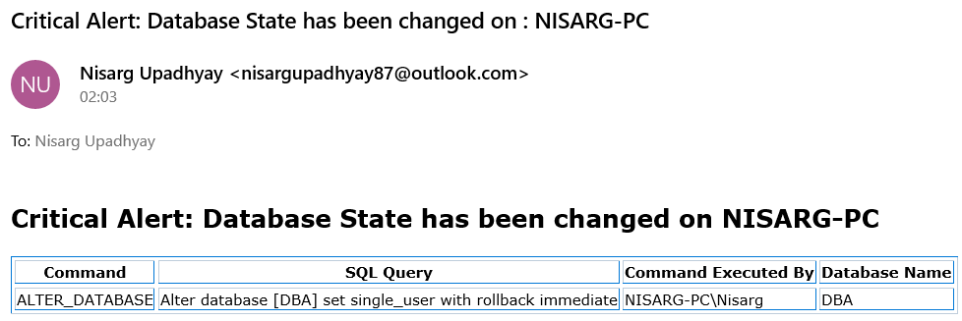
Note:
If a Login changes multiple user DB’s Status from ONLINE to OFFLINE, then we will receive individual HTML Notifications to our specified mail id instead of 1 single mail.

